# **Practical – 7**

**AIM: Draw Data Flow Diagram (DFD) for selected application.**

**Data Flow Diagram:**

* 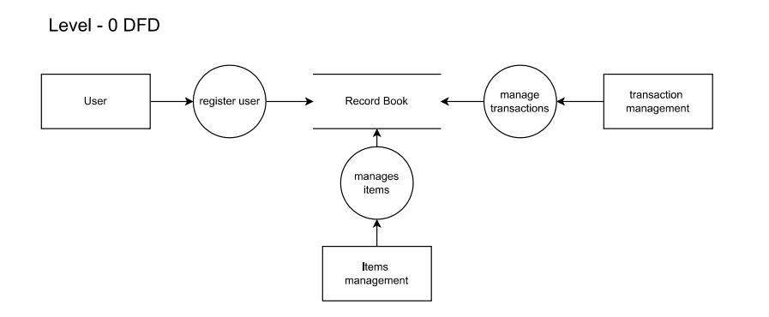**Level 0:**
* 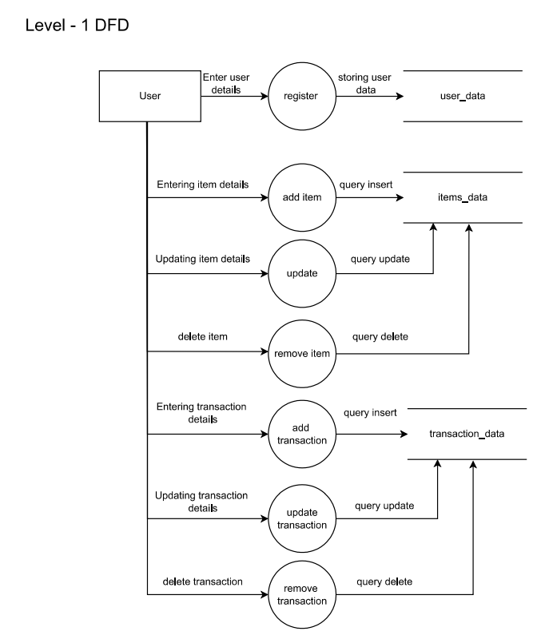**Level 1:**
* 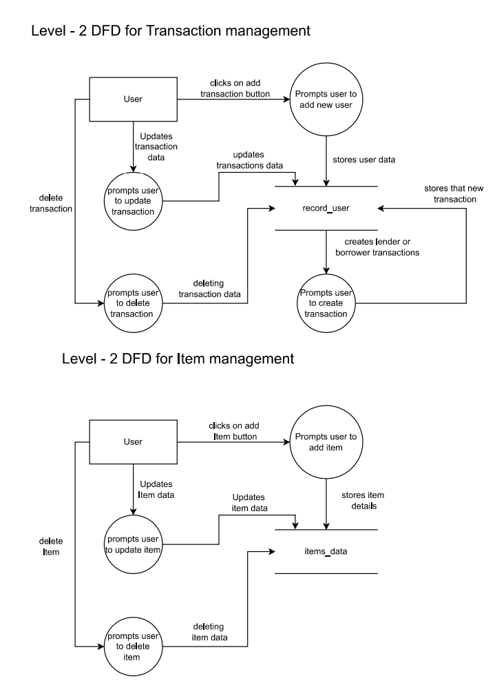**Level 2:**